Name: Talha Abdullah Bangyal
Roll Number: 22F-3194
Section: BAI-3A
Lab: 5
--------------------------------------------------------------------
Starter Task 1
#include<iostream>
using namespace std;
class IntStack
{
private:
int* stackArray;
int stackSize;
int top;
public:
IntStack(int);

~IntStack();
bool push(int);
bool pop(int&);
bool isFull();
bool isEmpty();
};

IntStack::IntStack(int size) //constructor
{
stackArray = new int[size];
stackSize = size;
top = -1;
}

IntStack::~IntStack(void) //destructor

{
delete[] stackArray;

}

bool IntStack::isFull(void)
{
if (top == stackSize - 1)
return true;
else
return false;
// return (top == stackSize-1);
}

bool IntStack::isEmpty(void)
{
return (top == -1);
}

bool IntStack::push(int num)
{
if (isFull())
{
cout << "The stack is full.\n";
return false;
}
top++;
stackArray[top] = num;
return true;
}

bool IntStack::pop(int& num)
{
if (isEmpty())
{
cout << "The stack is empty.\n";
return false;
}
num = stackArray[top];
top--;
return true;
}

int main() {

}
Starter Task 2
#include<iostream>
using namespace std;
class node {
public:
int data; node* next;
};

class Stack {
node* top;
public:
Stack();
~Stack();
void Push(int newelement);
bool Pop(int&);
bool IsEmpty();
void makeNull();
};

Stack::Stack() {
top = NULL;
}

bool Stack::IsEmpty() {
return (top == NULL);
}

void Stack::Push(int newelement) {
node* newptr = new node;
newptr->data = newelement;
newptr->next = top;
top = newptr;
}

bool Stack::Pop(int& returnvalue) {
if (IsEmpty()){
cout << "underflow error";
return false;
}
node* tempptr = top;
returnvalue = top->data;
top = top->next;
delete tempptr;
return true;
}

void Stack::makeNull() {
int x;
while (Pop(x));
}

Stack::~Stack() {
makeNull();
}

int main() {

}
Task 1
#include<iostream>
#include<string>
using namespace std;

struct node {
char data;
node* next;
};

class Stack {
node* top;
public:
Stack() { top = NULL; }
~Stack() { makeNull(); }
void Push(char newelement);
bool Pop(char&);
bool IsEmpty();
void makeNull();
char Top();
};

void Stack::Push(char newelement) {
node* newptr = new node;
newptr->data = newelement;
newptr->next = top;
top = newptr;
}

bool Stack::Pop(char& returnvalue) {
if (IsEmpty()) {
cout << "underflow error\n";
return false;
}
node* tempptr = top;
returnvalue = top->data;
top = top->next;
delete tempptr;
return true;
}

bool Stack::IsEmpty() {
return (top == NULL);
}

void Stack::makeNull() {
char x;
while (Pop(x));
}

char Stack::Top() {
if (IsEmpty()) {
cout << "Stack is empty\n";
return '\0';
}
return top->data;
}

int precedence(char c) {
if (c == '+' || c == '-')
return 1;
else if (c == '*' || c == '/')
return 2;
else
return 0;
}

void infixToPostfix(string infix, string& postfix) {
Stack s;
for (int i = 0; i < infix.length(); i++) {
if (infix[i] == ' ') continue;
else if (infix[i] == '(') s.Push(infix[i]);
else if (infix[i] == ')') {
char c;
while (!s.IsEmpty() && s.Top() != '(') {
s.Pop(c);
postfix += c;
}
if (s.IsEmpty() || s.Top() != '(') {
cout << "Invalid infix expression\n";
return;
}
s.Pop(c);
}
else if (isalpha(infix[i])) postfix += infix[i];
else {
while (!s.IsEmpty() && s.Top() != '(' && precedence(s.Top()) >= precedence(infix[i])) {
char c;
s.Pop(c);
postfix += c;
}
s.Push(infix[i]);
}
}
while (!s.IsEmpty()) {
char c;
s.Pop(c);
postfix += c;
}
}

int main() {
string infix, postfix;
cout << "Enter infix expression: ";
getline(cin, infix);
infixToPostfix(infix, postfix);
cout << "Postfix expression: " << postfix << endl;
return 0;
}
Task 2
#include<iostream>
#include<string>
using namespace std;

struct node {
char data;
node* next;
};

class Stack {
node* top;
public:
Stack() { top = NULL; }
~Stack() { makeNull(); }
void Push(char newelement);
bool Pop(char&);
bool IsEmpty();
void makeNull();
char Top();
};

void Stack::Push(char newelement) {
node* newptr = new node;
newptr->data = newelement;
newptr->next = top;
top = newptr;
}

bool Stack::Pop(char& returnvalue) {
if (IsEmpty()) {
cout << "underflow error";
return false;
}
node* tempptr = top;
returnvalue = top->data;
top = top->next;
delete tempptr;
return true;
}

bool Stack::IsEmpty() {
return (top == NULL);
}

void Stack::makeNull() {
char x;
while (Pop(x));
}

char Stack::Top() {
if (IsEmpty()) {
cout << "Stack is empty";
return '\0';
}
return top->data;
}

int precedence(char c) {
if (c == '+' || c == '-')
return 1;
else if (c == '*' || c == '/')
return 2;
else
return 0;
}

void infixToPrefix(string infix, string& prefix) {
Stack s;
string temp = infix;
reverse(temp.begin(), temp.end());
for (int i = 0; i < temp.length(); i++) {
if (temp[i] == ' ') continue;
else if (temp[i] == '(') {
char c;
while (!s.IsEmpty() && s.Top() != ')') {
s.Pop(c);
prefix += c;
}
if (s.IsEmpty() || s.Top() != ')') {
cout << "Invalid infix expression";
return;
}
s.Pop(c);
}
else if (temp[i] == ')') s.Push(temp[i]);
else if (isalpha(temp[i])) prefix += temp[i];
else {
while (!s.IsEmpty() && s.Top() != ')' && precedence(s.Top()) >= precedence(temp[i])) {
char c;
s.Pop(c);
prefix += c;
}
s.Push(temp[i]);
}
}
while (!s.IsEmpty()) {
char c;
s.Pop(c);
prefix += c;
}
reverse(prefix.begin(), prefix.end());
}

int main() {
string infix, prefix;
cout << "Enter infix expression: ";
getline(cin, infix);
infixToPrefix(infix, prefix);
cout << "Prefix expression: " << prefix << endl;
return 0;
}
Task 3
#include<iostream>
#include<string>
using namespace std;

struct node {
char data;
node* next;
};

class Stack {
node* top;
public:
Stack() { top = NULL; }
~Stack() { makeNull(); }
void Push(char newelement);
bool Pop(char&);
bool IsEmpty();
void makeNull();
char Top();
};

void Stack::Push(char newelement) {
node* newptr = new node;
newptr->data = newelement;
newptr->next = top;
top = newptr;
}

bool Stack::Pop(char& returnvalue) {
if (IsEmpty()) {
cout << "underflow error";
return false;
}
node* tempptr = top;
returnvalue = top->data;
top = top->next;
delete tempptr;
return true;
}

bool Stack::IsEmpty() {
return (top == NULL);
}

void Stack::makeNull() {
char x;
while (Pop(x));
}

char Stack::Top() {
if (IsEmpty()) {
cout << "Stack is empty";
return '\0';
}
return top->data;
}

int precedence(char c) {
if (c == '+' || c == '-')
return 1;
else if (c == '*' || c == '/')
return 2;
else if (c == '!' || c == '~' || c == '+' + 256 || c == '-' + 256) // unary operators
return 3;
else
return 0;
}

void infixToPostfix(string infix, string& postfix) {
Stack s;
for (int i = 0; i < infix.length(); i++) {
if (infix[i] == ' ') continue;
else if (infix[i] == '(') s.Push(infix[i]);
else if (infix[i] == ')') {
char c;
while (!s.IsEmpty() && s.Top() != '(') {
s.Pop(c);
postfix += c;
}
if (s.IsEmpty() || s.Top() != '(') {
cout << "Invalid infix expression";
return;
}
s.Pop(c);
}
else if (isalpha(infix[i])) postfix += infix[i];
else if (infix[i] == '!' || infix[i] == '~' || infix[i] == '+' + 256 || infix[i] == '-' + 256) { // unary operators
s.Push(infix[i]);
}
else {
while (!s.IsEmpty() && s.Top() != '(' && precedence(s.Top()) >= precedence(infix[i])) {
char c;
s.Pop(c);
postfix += c;
}
s.Push(infix[i]);
}
}
while (!s.IsEmpty()) {
char c;
s.Pop(c);
postfix += c;
}
}

int main() {
string infix, postfix;
cout << "Enter infix expression: ";
getline(cin, infix);
infixToPostfix(infix, postfix);
cout << "Postfix expression: " << postfix << endl;
return 0;
}
Task 4 (1)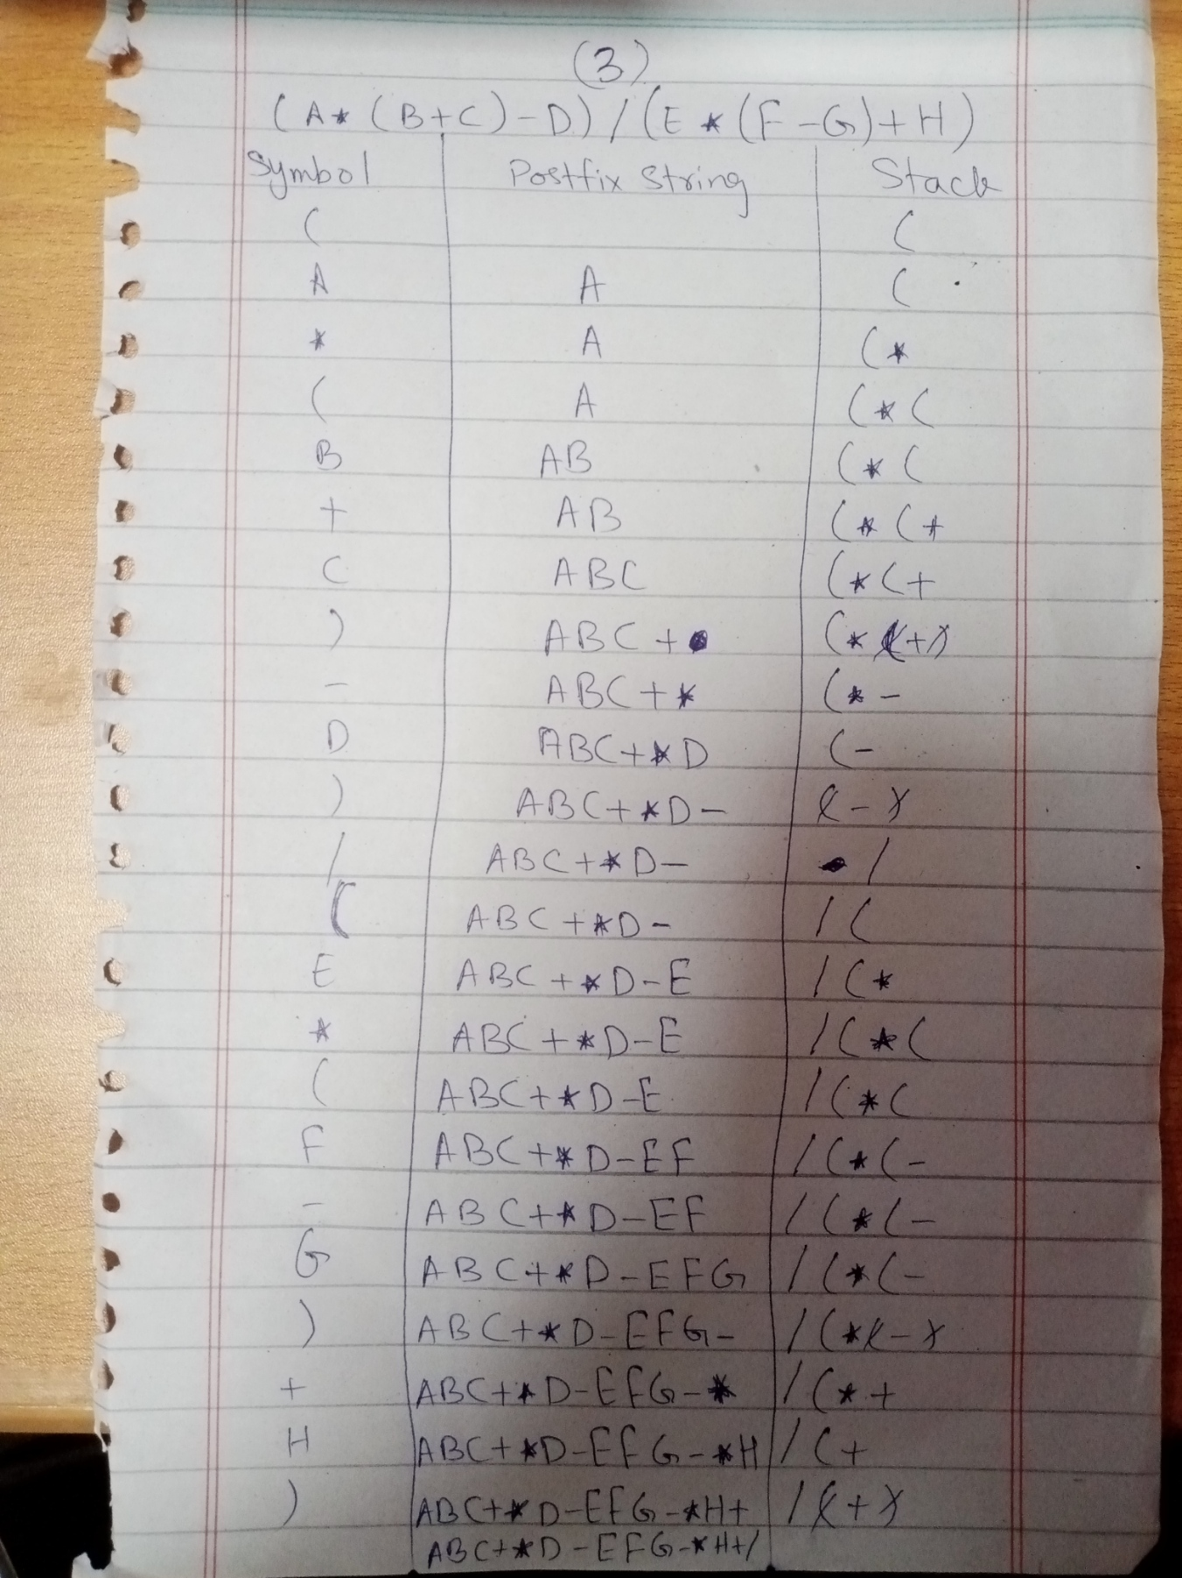

Task 4 (3)
